
Lab assignment 3
Submitted by: Tayyaba Hussein
Registration: SP24-BSE-059
Course: Information security (lab)
Instructor: Ms. Ambreen Gul
Program: Software engineering

- Search about latest attack on key exchange algorithms and provide its implementation in python.

Code:
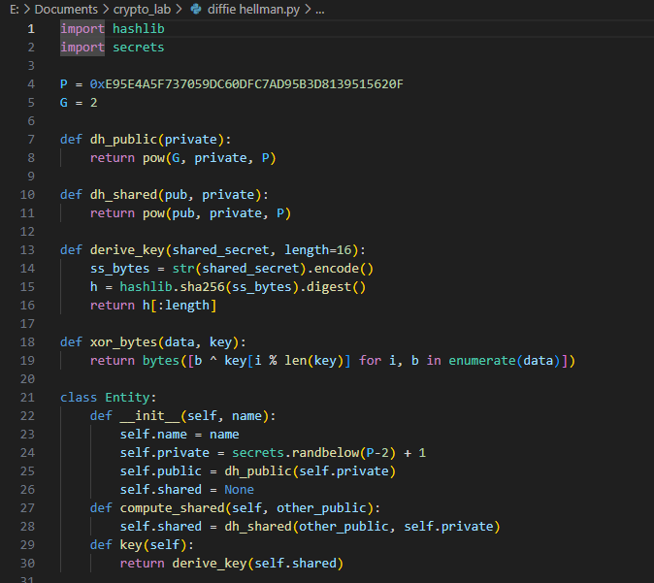

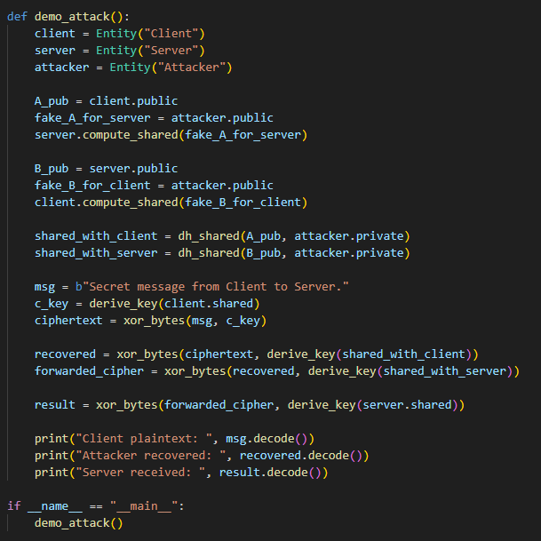
Output:
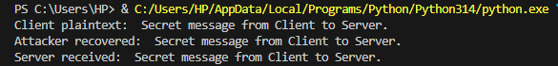

Explanation:
This code shows how an attacker can secretly sit between a client and a server during a Diffie–Hellman key exchange. Instead of letting them exchange their real public keys, the attacker sends its own public key to both sides. As a result, the client shares a secret with the attacker, and the server also shares a different secret with the attacker — but neither side knows this happened. When the client sends an encrypted message, the attacker uses its shared secret to decrypt the message, read it, and then re-encrypt it using the secret shared with the server. This way, the server still gets the correct message, but the attacker has read everything in the middle without being detected.

